**Raspberry Pi 4B**

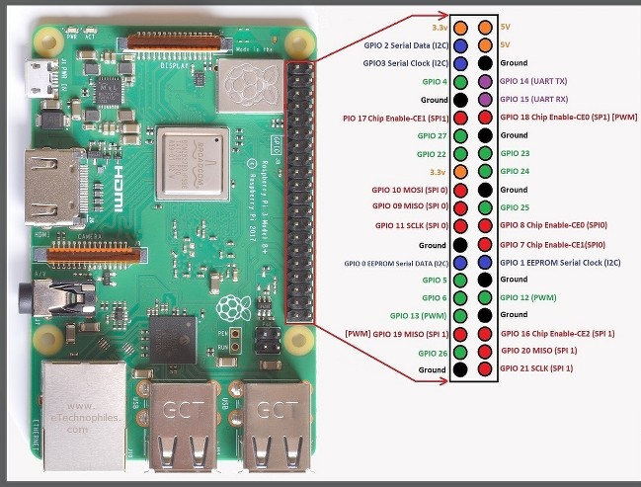

**Motor Driver**

**IBT_2**

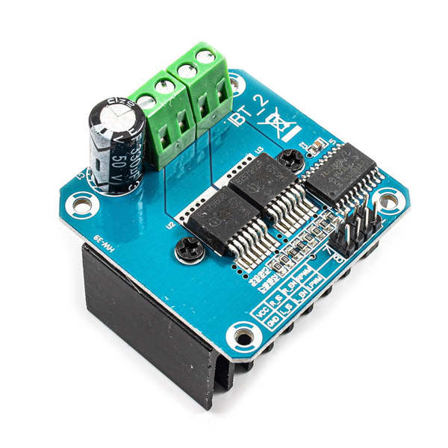

**This module has 12 pins:**

**Microcontroller pins (Low current):**

* VCC: Module power supply – 5V
* GND: Ground
* IS-R: Input signal for detecting high current – Straight rotation
* IS-L: Input signal for detecting high current – Inverse rotation
* EN-R: Output Signal for controlling motor direction – Straight rotation
* EN-L: Output Signal for controlling motor direction – Inverse rotation
* WM-R: PWM Signal for controlling motor speed – Straight rotation
* PWM-L: PWM Signal for controlling motor speed – Inverse rotation

**Motor pins (High current):**

* M+: Motor Positive
* M-: Motor negative
* B+: Battery positive
* B+: Battery negative

**MONSTER**

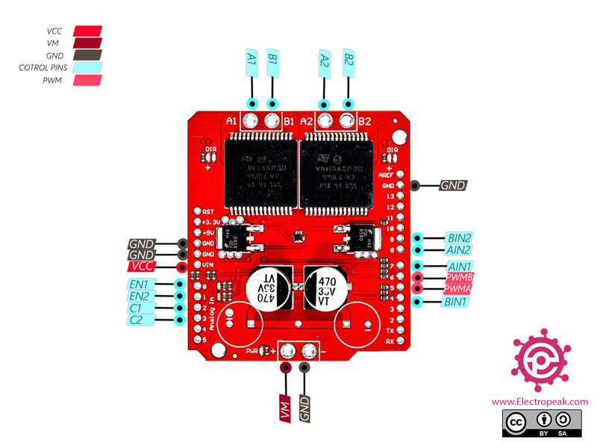

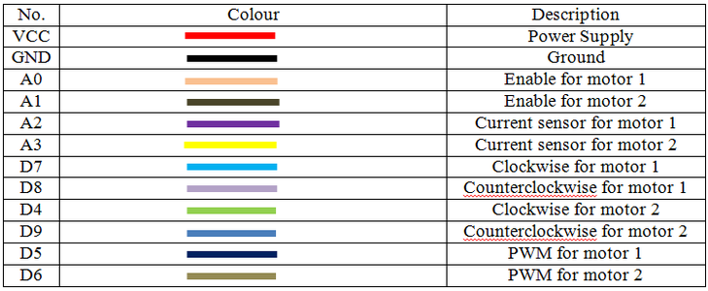

**Cytron**

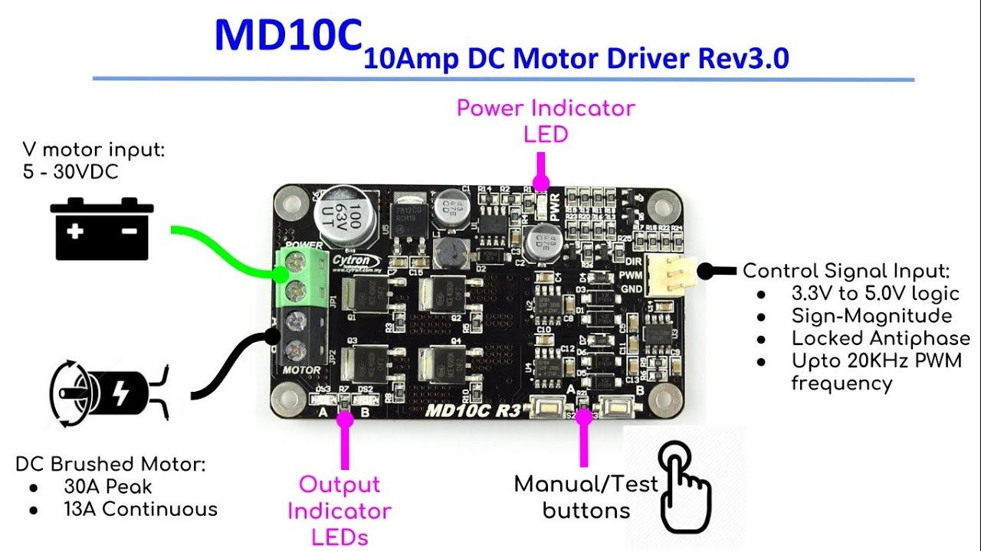

**MPU9250**

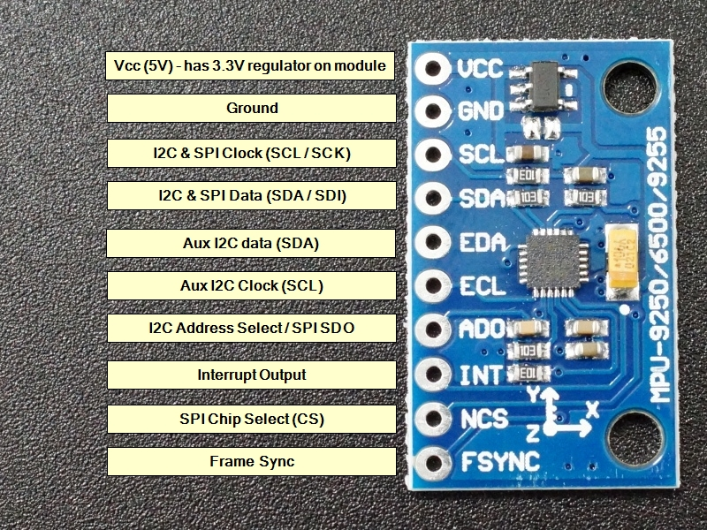

**ARDUINO**

